740TK

750TK

300TK

320RK

850Tk

800TK

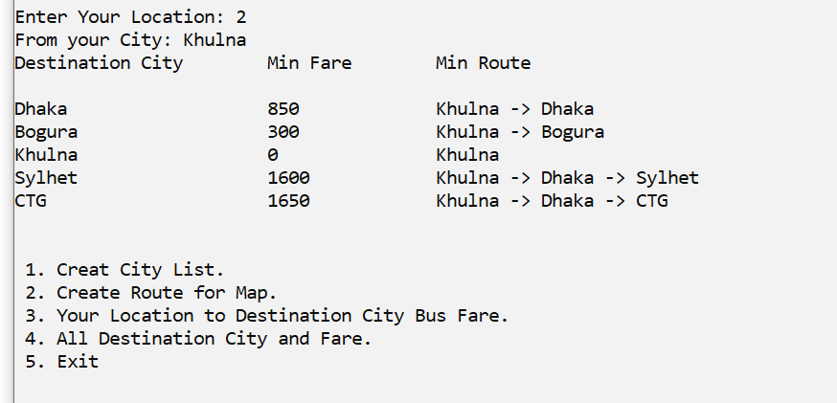

5

6

0 1

740

0 2

850

0 3

750

0 4

800

1 2

300

3 4

320